**A GESTURE BASED TOOL FOR STERILE BROWSING OF RADIOLOGY IMAGES**

**ABSTRACT:**

In this paper, we focus on using pointing behavior for a natural interface, Hand gesture recognition based human-machine interface is being developed vigorously in recent years. Due to the effect of lighting and complex background, most visual hand gesture recognition systems work only under restricted environment. To classify the dynamic hand gestures, we developed a simple and fast motion history image based method. In recent years, the gesture control technique has become a new developmental trend for many human-based electronics products. This technique let people can control these products more naturally, intuitively and conveniently. In this paper, a fast gesture recognition scheme is proposed to be an interaction (HMI) of systems. This paper presents some low-complexity algorithms and gestures to reduce the gesture recognition complexity and be more suitable for controlling real-time computer systems.

**1. INTRODUCTION:**

Interactive presentation systems use advanced Human Computer Interaction (HCI) techniques to provide a more convenient and user-friendly interface for controlling presentation displays, such as page up/down controls in a slideshow. Compared with traditional mouse and the interface for human-machine keyboard control, new aexperience is significantly improved with these techniques. Hand gesture has wide- ranging applications. In this study, we apply it to an interactive presentation system to create an easy-to-understand interaction interface.

**2. EXISTING SYSTEM:**

In recent decades, due to computer software and hardware technologies of continuous innovation and breakthrough, the social life and information technology have a very close relationship in the twenty-first century. In the future, especially the interfaces of consumer electronics products (e.g. smart phones, games and infota1inment systems) will have more and more functions and be complex. How to develop a convenient human-machineInterface (HumanMachine Interaction/Interface, HMI) for each consumer electronics product has become an important issue. The traditional electronic input devices, such as mouse, keyboard, and joystick are still the most common interaction way. However, it does not mean that these devices are the most convenient and natural input devices for most users. Since ancient times, gestures are a major way for communication and interaction between people. People can easily express the idea by gestures before the invention of language. Nowadays, gestures still are naturally used by many people and especially are the most major and nature interaction way for deaf people . In recent years, the gesture control technique has become a new developmental trend for many human- based electronics products, such as computers, televisions, and games. This technique let people can control these products more naturally, intuitively andIn case of existing system . The objective of this paper is to develop a real time hand gesture recognition system based on adaptive color HSV model and motion history image (MHI). By adaptive skin color model, the effects from lighting, environment, and camera can be greatly reduced, and the robustness of hand gesture recognition could be greatly improved.

**3.PROBLEM STATEMENT:**

“Hand Gesture Recognition Using Camera ” is based on concept of Image processing. In recent year there is lot of research on gesture recognition using kinect sensor on using HD camera but camera and kinect sensors are more costly. This paper is focus on reduce cost and improve robustness of the proposed system using simple web camera.

**4. PROPOSED SYSTEM:**

Most gesture recognition methods usually contain three major stages. The first stage is the object detection. The target of this stage is to detect hand objects in the digital images or videos. Many environment and image problems are needed to solve at this stage to ensure that the hand contours or regions can be extracted precisely to enhance the recognition accuracy. Common image problems contain unstable brightness, noise, poor resolution and contrast. The better environment and camera devices can effectively improve these problems. However, it is hard to control when the gesture recognition system is working in the real environment or is become a product. Hence, the image processing method is a better solution to solve these image problems to construct an adaptive and robust gesture recognition system. The second stage is object recognition. The detected hand objects are recognized to identify the gestures. At this stage, differentiated features and effective classifiers selection are a major issue in most researches. The third stage is to analyze sequential gestures to identify users’ instructs or behaviors.

**5. SYSTEM ARCHITECTURE:**

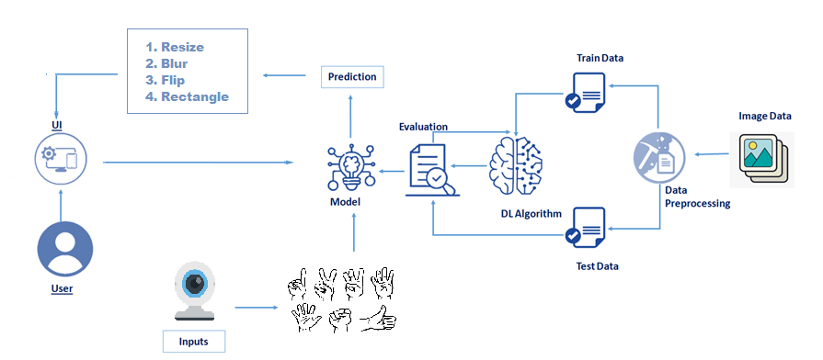

**6. ADVANTAGES:**

* Reduce external Interface :

The Advantage of System is to External Interface like Mouse And Keyboard.

* High Portability:

The proposed System reduce the working of external interface like keyboard and mouse so it makes it high portable.

**7. CONCLUSION:**

The proposed work will help to eliminate the traditionally completely. It only require web-camera to capture I/P image. This would lead to a new generation of human computer interaction in which no physical contact with device is needed. Anyone can use the system to operate the computer easily, by using gesture command.

**8. REFERENCES:**

[1]Robust Part-Based Hand Gesture Recognition Using Kinect SensorZhou Ren, Junsong Yuan, Member, IEEE, Jingjing Meng, Member, IEEE, and Zhengyou Zhang, Fellow, IEEE, 15, AUGUST 2013

[2] A Fast Gesture Recognition Scheme for Real-Time Human-Machine Interaction Systems . Ching-Hao Lai* Smart Network System Institute Institute for Information Industry Taipei City, Taiwan , 2010.

[3] Real-Time Hand Gesture Recognition System for Daily Information Retrieval fromInternet 1633 IEEE Fourth International Conference on Ubi-Media Computing.

[4] Wearable Sensor-Based Hand Gesture and Daily Activity Recognition for Robot- Assisted Living IEEE Transactions on systems, Man , and Cybernetics Part A: Systems and humans, Vol .41, No. 3, May 2011.

[5] A Hand Gesture Based Interactive Presentation System Utilizing Heterogeneous Cameras Bobo Zeng, Guijin Wang**, Xinggang Lin.